**GCSE Probability Tree Questions**

**Example:**

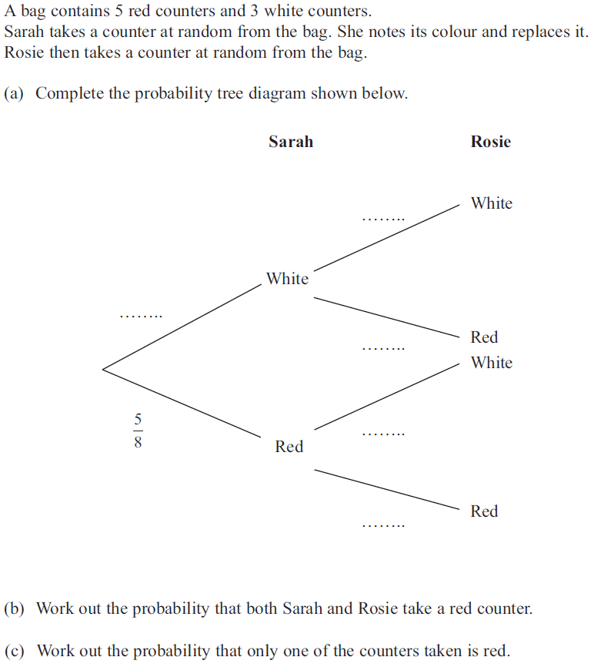

**Question 1**

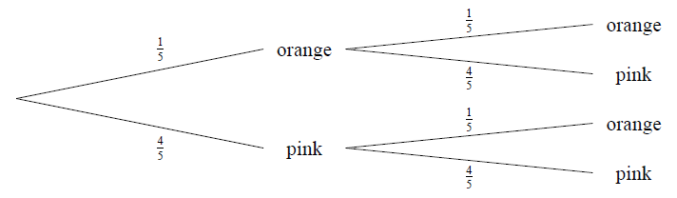

What’s the probability of getting:

1. Orange twice? _____________
2. Seeing different colours? _____________
3. Seeing the same colour twice? _____________

**Question 2**The probability of getting Heads on a biased coin is 0.9.

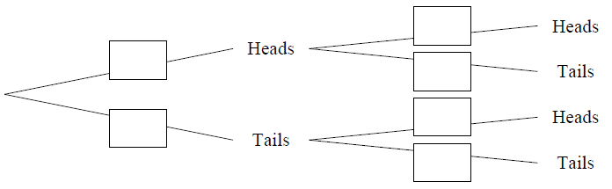a) Complete the tree diagram.  
b) What is the probability of getting Heads twice? __________  
  
c) What is the probability of seeing one each of Heads and Tails? __________

**Question 3**A bag contains the letters of ‘TRANSFORMATION’. I pick two letters from the bag without replacement.

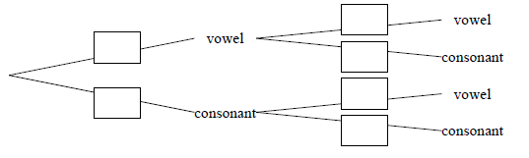

1. Complete the probability tree.
2. What is the probability of getting two consonants? _____________
3. What is the probability of getting exactly one vowel? _____________

**Question 4**

There are 3 purple sweets and 7 blue sweets in a bag. I take two sweets without replacement.  
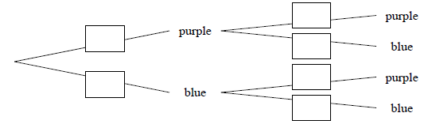  
a) Complete the probability tree.  
  
b) What is the probability that I get two sweets of different colours? _____________  
  
a) What is the probability that I get two sweets of the same colour? _____________

**Question 5 – “The Birthday Paradox”**

You wish to find the probability that in a classroom of 30 people, at least two share the same birthday.

1. It is easier to work out the probability first that no one shares the same birthday. Presuming a year is 365 days, what is the probability that the second person in the room doesn’t share a birthday with the first?  
     
   _________________
2. What is the probability that the third person doesn’t share a birthday with either of the first two?  
     
   _________________
3. Hence work out the probability that in the classroom, no one shares a birthday.  
     
   _________________
4. Hence work out the probability that at least two people share a birthday.  
     
   _________________

**Question 6**

**[Nov 2011 NonCalc]** Jan has two boxes. There are 6 black and 4 white counters in box A.

There are 7 black and 3 white counters in box B.

Jan takes at random a counter from box A and puts it in box B.

She then takes at random a counter from box B and puts it in box A.

(a) Complete the probability tree diagram.



**(2)**

(b) Find the probability that after Jan has put the counter from box B into box A there will still be 6 black counters and 4 white counters in box A.

.....................................

**(4)**

**Algebraic Trees**

In these questions, some quantity or probability will be unknown, but the final probability will be known. Represent any unknowns as variables and solve as you would have before to get an equation.

**Question 7**A box contains a total of 4 balls; some are purple and the rest pink. A ball is chosen at random, replaced before choosing again. If $P\left(two purple\right)=\frac{1}{16}$ then determine the number of purple balls.

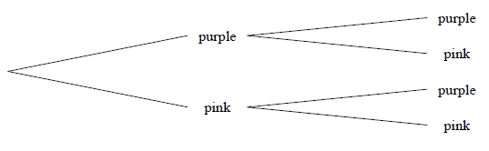

___________________  
  
**Question 8**  
A bag contains a total of 10 sweets; some are brown and the rest are grey. A sweet is chosen at random and not replaced before choosing another one. If $P\left(two brown\right)=\frac{28}{45}$ then find $P(two grey)$.  
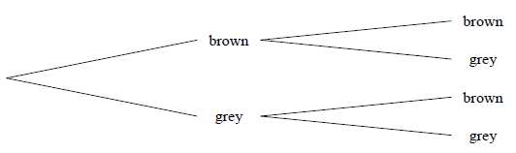  
  
____________________

**Question 1**

[Maclaurin 2011 Q2] I have 44 socks in my drawer, each either red or black. In the dark I randomly pick two socks, and the probability that they do not match is $\frac{192}{473}$. How many of the 44 socks are red?

**Question 2**

[Maclaurin 2013 Q4] Two coins are biased in such a way that, when they are both tossed once:   
(i) the probability of getting two heads is the same as the probability of getting two tails;   
(ii) the probability of getting one head and one tail is $\frac{5}{8}$.   
For each coin, what is the probability of getting a head?